同步练习6.1 二.2

#include<iostream>

using namespace std;

class student

{ public:

void input(student &stu);

void output(student &stu);

private:

char name[20] = { "\0" };

unsigned int id=0;

double score=0;};

void student::input(student &stu)

{ cout << "name?";

cin >> stu.name;

cout << "id?";

cin >> stu.id;

cout << "score?";

cin >> stu.score;

}

void student::output(student &stu)

{ cout << "name:" << stu.name << "\tid:" << stu.id << "\tscore:" << stu.score << endl;

}

int main()

{ student s;

s.input(s);

s.output(s);

}

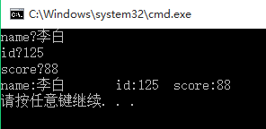

1. 综合练习二.1

#include<iostream>

using namespace std;

class Book

{ public:

void display();

void borrow();

void restore();

char bookname[60] = "小王子";

double price=22.5;

int number=50;

};

void Book::display()

{ cout << "书名：" << bookname << endl;

cout << "价格：" << price << endl;

cout << "存数数量：" << number << endl;

}

void Book::borrow()

{ number -= 1;

cout<<"借走1本\t"<< "当前存书数量：" << number << endl;

}

void Book::restore()

{ number += 1;

cout <<"归还1本\t"<< "当前存书数量：" << number << endl;

}

int main()

{ Book b;

b.display();

b.borrow();

b.restore();

}

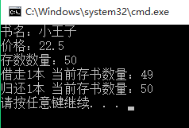

1. 综合练习二.3

#include<iostream>

using namespace std;

class student

{

public:

int score;

static double total, count;

void scoretotalcount(double s);

static int sum()

{

return total;

}

static double average()

{

return total / count;

}

};

double student::total = 0;

double student::count = 0;

void student::scoretotalcount(double s)

{

score = s;

total += score;

count += 1;

}

int main()

{

student stu;

double s;

int w;

while (1)

{

cout << "请输入：1-输入学生分数,0-结束\n";

cin >> w;

switch (w)

{

case(1) :

{cout << "请输入分数：";

cin >> s;

stu.scoretotalcount(s);

cout << "当前总分：" << stu.sum() << '\n'

<< "平均值：" << stu.average() << endl;

break;

}

case(0) : return 0;

}

}

}

